|  |  |  |
| --- | --- | --- |
| Project Settings: Sync not complete  Please view project settings before start | | |
| Project Check Sheet:  Please use check sheet after completing this task | | |

1. **Task Requirement / Description**
2. **UI Flow**
3. **Programming Logic**
4. **Database**

**1. Task Requirement / Description**

Customer needs a way to change the sort order for categories in the admin and live site.

In the admin please sort 1st by category level then 2nd sort by new db field sortOrder

In the admin site add a column to the category view next to options with up and down arrow so customer can move the category order

Update the clip2 site in staging url <http://staging.centralinfo.com.au/devsites/mer-wwwclip2/> so that the categories are displayed in order of the new sortOrder field.

**2. UI Flow**



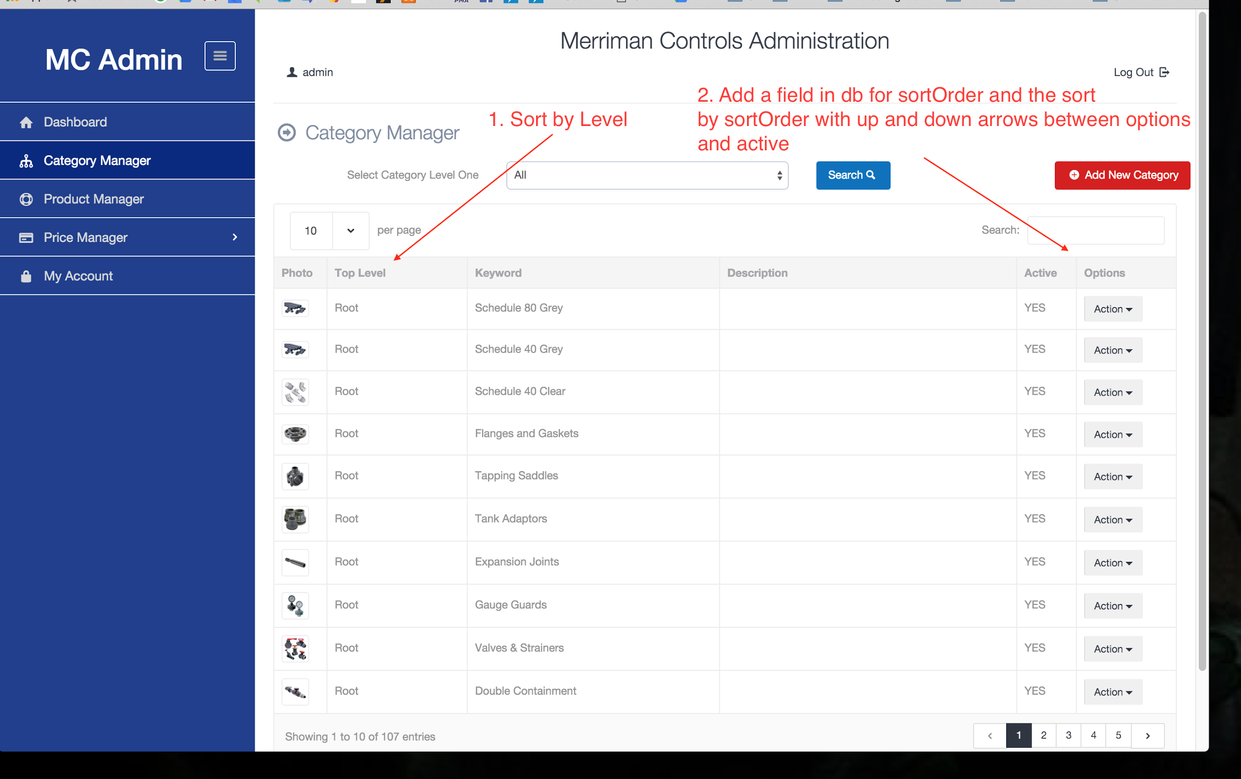

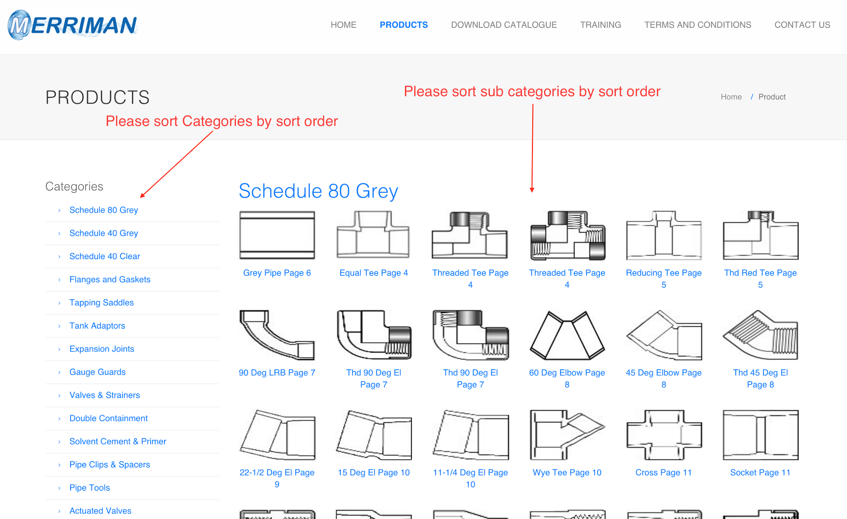

**3. Programming Logic**

* Clip2 site: Keep current logic but sort by new sort field
* Admin: Keep currect logic but sort by category level and then sort field

**4. Database**

Add new field to category table sortOrder (int) default 0

END